Scottish Football commits to sustainability as COP26 takes place in Glasgow
Why Scottish football clubs are keeping an eye on an English league two team…
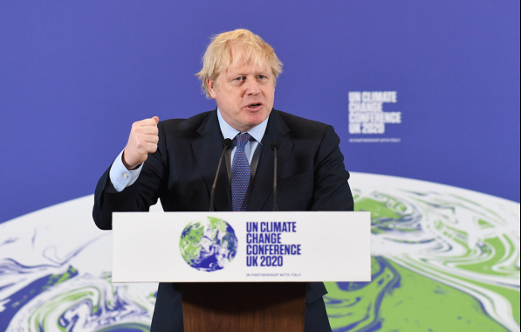
"Boris Johnson launch of COP26" by UK Prime Minister is licensed with CC BY-NC-ND 2.0. To view a copy of this license, visit https://creativecommons.org/licenses/by-nc-nd/2.0/

Thanks to COP26, Scottish football has now announced what it is aiming to do to help tackle climate change.
The Scottish Professional Football League (SPFL) and the Scottish Football Association (SFA) released a joint statement during the Glasgow conference with a number of ways to show how the game will be moving in a greener direction.
However, one team which is based in the fourth tier of the English professional leagues has been at the top of the eco division for a while now.
"Forest Green Rovers v Tranmere National League Play Off Final 2017 Wembley" by kennysarmy is licensed with CC BY-NC-ND 2.0. To view a copy of this license, visit https://creativecommons.org/licenses/by-nc-nd/2.0/
Forest Green Rovers FC, are also known as ‘the world's greenest football club.’
The club based in Gloucestershire, England, installed many environmentally friendly features to their stadium including solar panels, electric car charging points, water recycling, an electric lawnmower, an organic pitch, and an vegan only menu for players and fans. Other ‘green’ highlights:
- Forest Green Rovers’ absolute carbon footprint has decreased by 3% since 2017.
- Its carbon footprint per spectator has decreased by 42% since the 2011/12 season.
- In 2016/17, the team recycled over 8% of the water used from the main water supply.
- The project decreased the amount of waste produced in the 2017/18 season by 14.7%.
- The Forest Green Rovers is the only club to have Eco-Management and Audit Scheme (EMAS) accreditation.
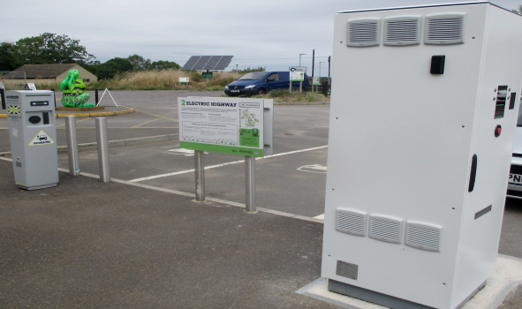
"Forest Green Rovers 1 Oldham Athletic 1, Football League Two 11.8.18" by Diego Sideburns is licensed with CC BY-NC-ND 2.0. To view a copy of this license, visit https://creativecommons.org/licenses/by-nc-nd/2.0/
The entire club is powered by 100% green energy from Ecotricity, some of which they generate themselves with the solar panels on the stadium roof and the solar tracker at the ground entrance.
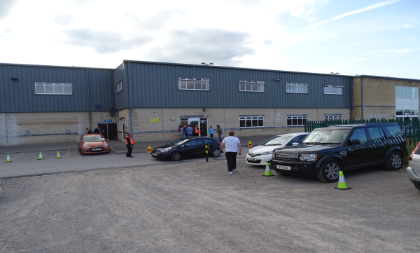
"The New Lawn Stadium" by joncandy is licensed with CC BY-SA 2.0. To view a copy of this license, visit https://creativecommons.org/licenses/by-sa/2.0/
The grass the club play on is sustainable, free from pesticides and weed killers, and they cut the grass with a GPS-directed, solar-powered lawnmower.
They also collect rainwater that lands on the terrace stands and use it to irrigate the pitch rather than using mains water.

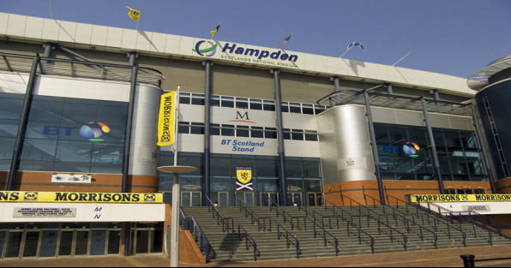
"Hampden Park" by raymccrae is licensed with CC BY 2.0. To view a copy of this license, visit https://creativecommons.org/licenses/by/2.0/
Last week, the SPFL and SFA released a joint statement on the state of the how our beautiful game can become kinder on the environment.
“The Scottish FA and Scottish Professional Football League are committed to playing their part in creating a more sustainable national game, with the home of Scottish football and the headquarters of the respective organisations, Hampden Park, at the forefront of measures to reduce the impact on our environment.”
“As the governing body, the Scottish FA has recently published its best practice guidelines, Environmental Sustainability in Scottish Football, and will commit to even more stringent measures as part of its new strategy, The Power of Scottish Football, over the next decade.”
“The Scottish FA has made significant improvements to the stadium as part of its co-hosting of UEFA EURO 2020 which have included:

• Upgrading floodlights to a new interactive and energy-efficient LED system.
• Upgrading all internal and external lighting to low energy LED
• Ongoing commitment to zero waste in landfill with our partners Zero Waste Scotland.
• Commitment to separating all office waste at source.
• Enhancement of active travel commitment, including new bike shelters and parking provision.
• EV charging points in the stadium car park.
• Transport Group formed to increase public transport provision, including additional train services and express bus services to and from the city centre.
• Vegan food counters and more sustainable packaging in the stadium bowl, with locally sourced suppliers to our new café menu.
• E-ticketing platform replacing manual ticket printing.
• In support of Scotland’s world-leading climate change targets, we have set out to reduce carbon emissions from energy, waste and water (currently 2802 tonnes of CO2e) by 10% by the end of this year. To help achieve this we will continue to:
• Send zero waste direct to landfill
• Achieve awards for environmental excellence
• Support all those that come through our gates to make healthy food choices
• Assist all stadium users and visitors in choosing active travel for their journeys
• Make improvements to our grounds to enhance biodiversity
• Reduce operating costs by improving stadium infrastructure
• Champion behavioural change to promote sustainability at our stadium
• Engage with the community to share Hampden as a community asset
• Deliver an accessible stadium that embraces our diverse spectators’ and visitors’ individual requirements”

